**Question 1**

**Create a sample table in postgres/mysql with following columns (15 Marks) Table Name : cdac_power_bi Column Name - varchar Id- integer Age- integer Dob - date**

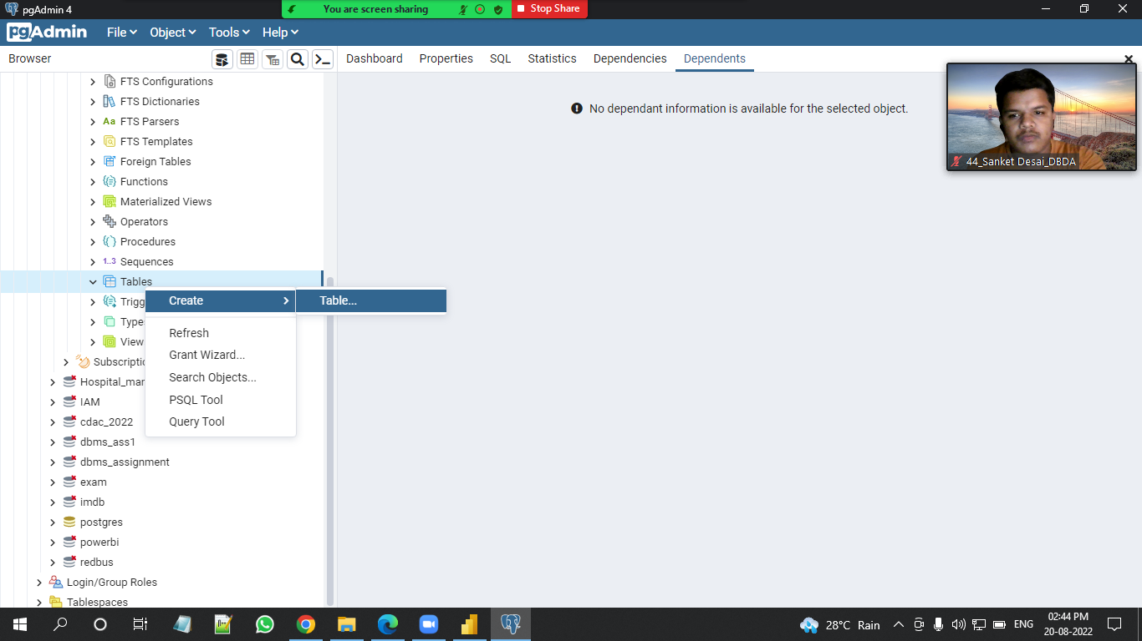

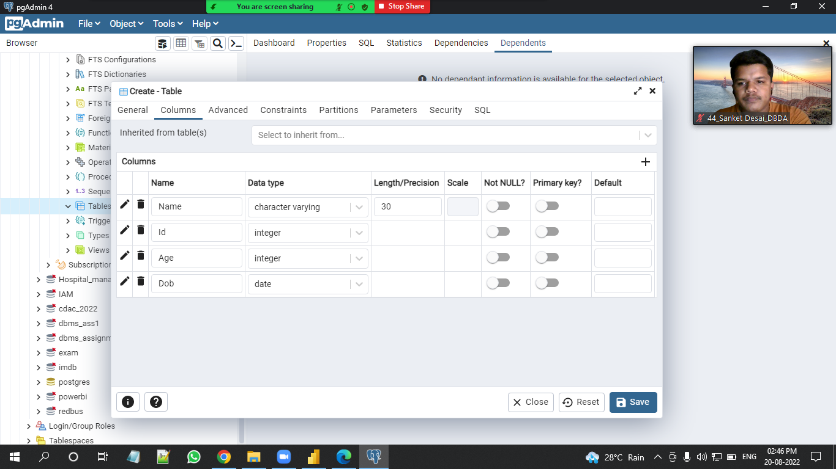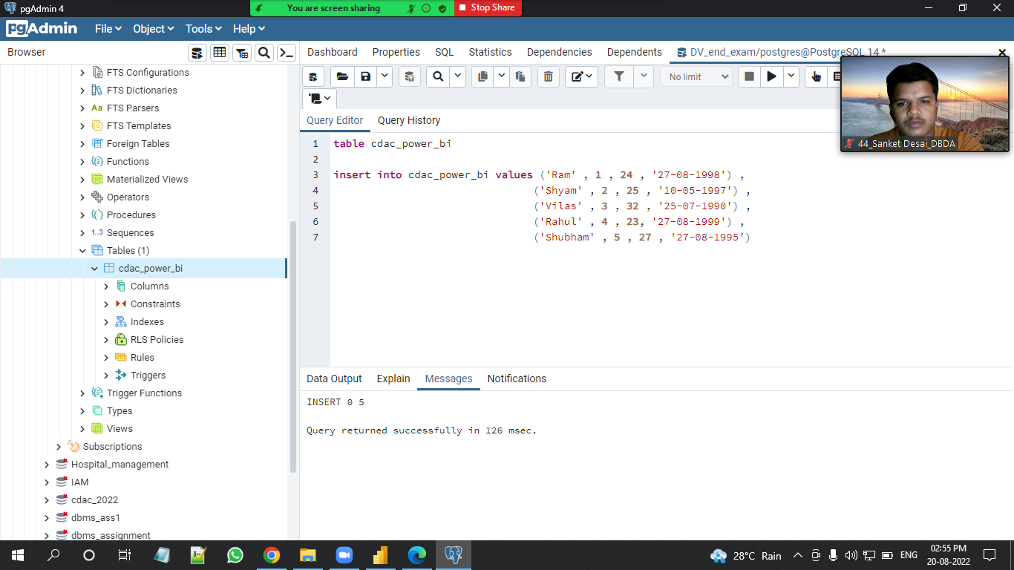

**Insert 5 dummy rows into it and then connect to superset and populate**

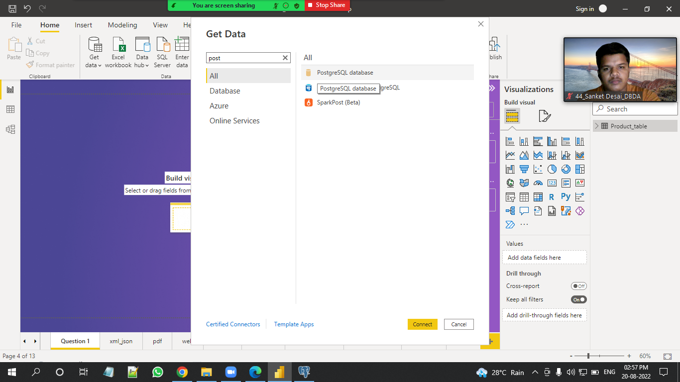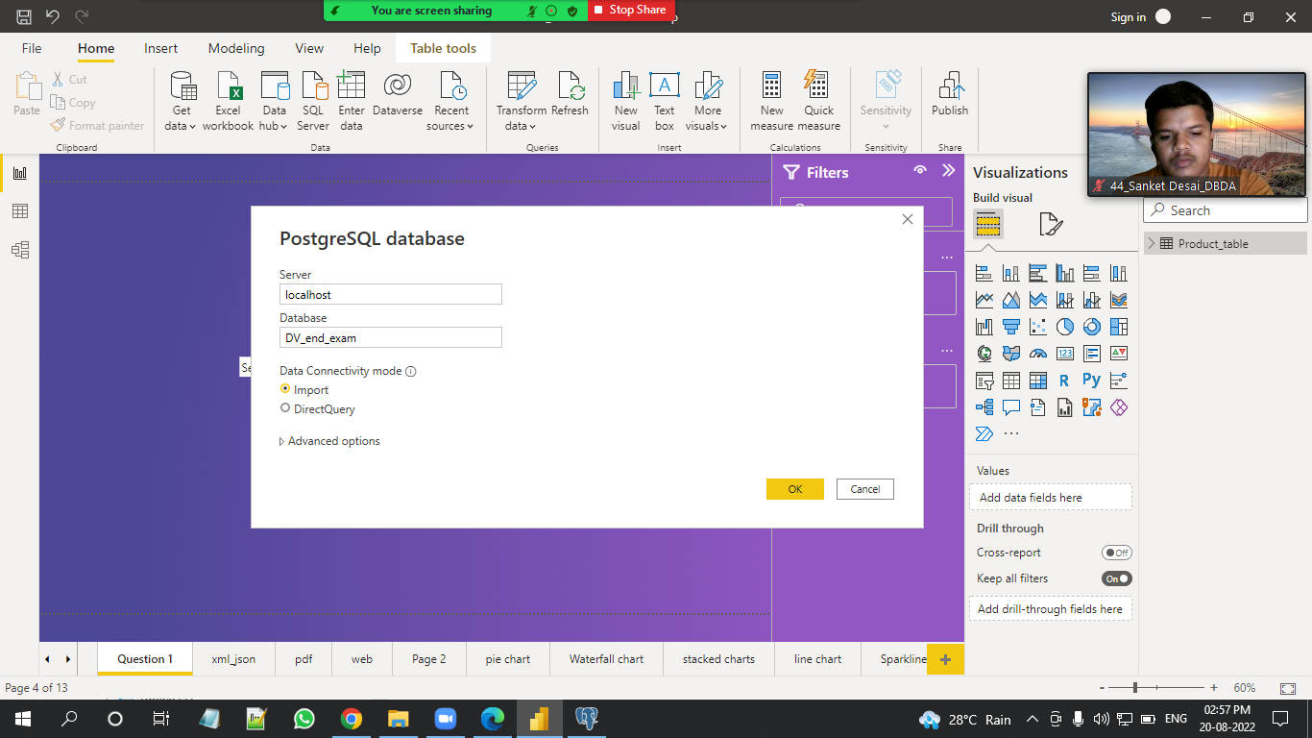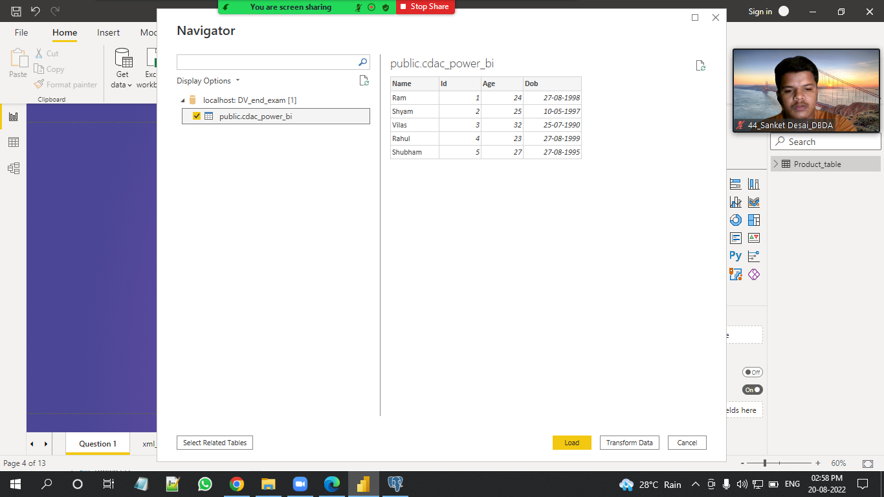

**1. Table Chart**

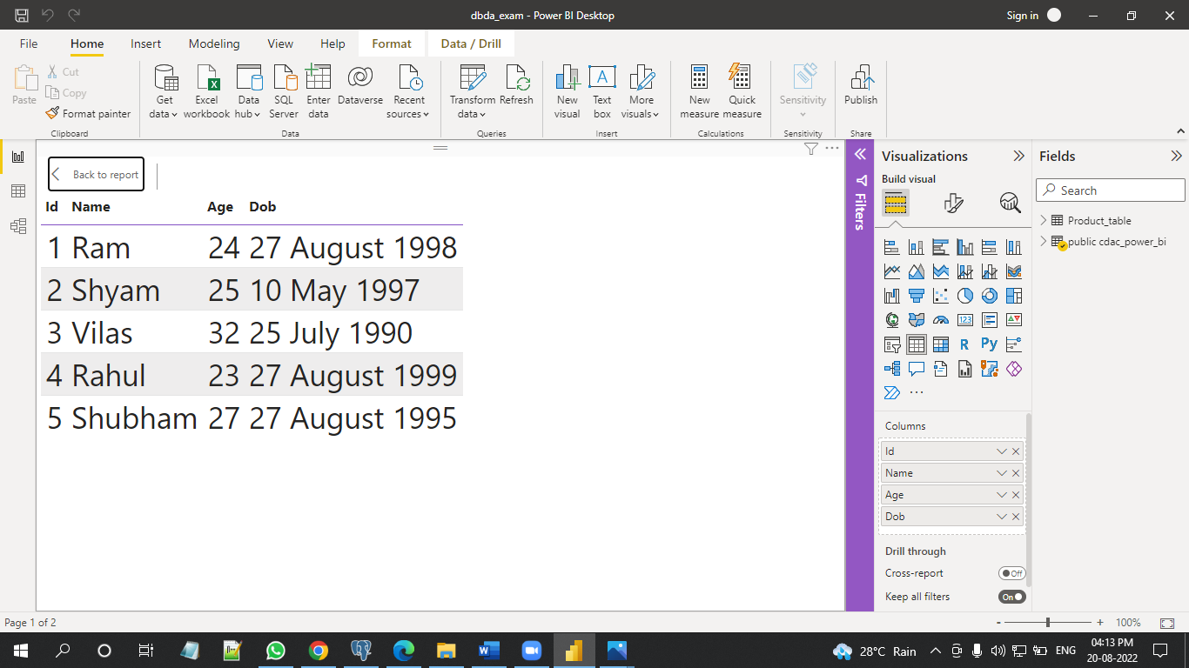

**Card chart showing max age**

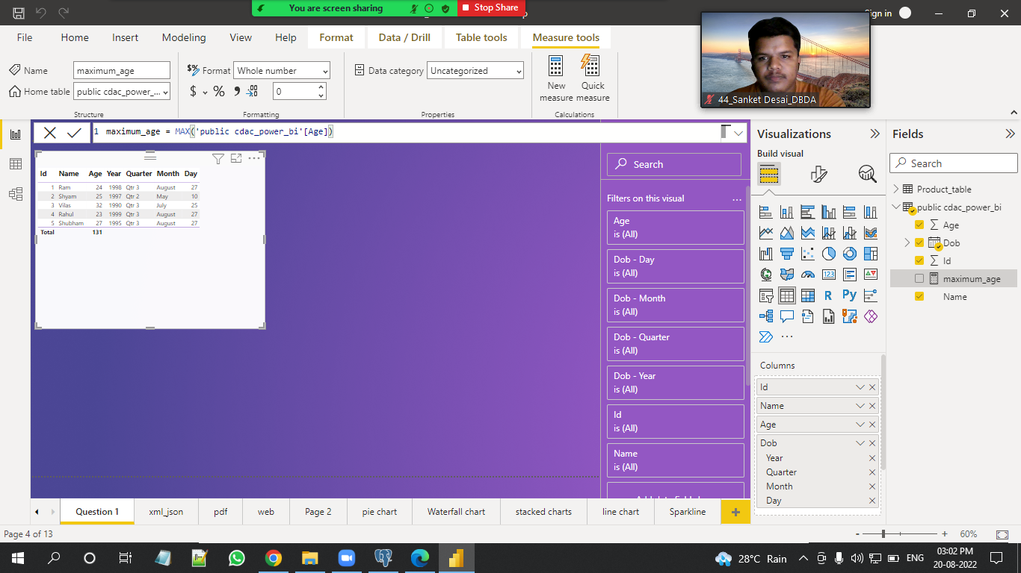

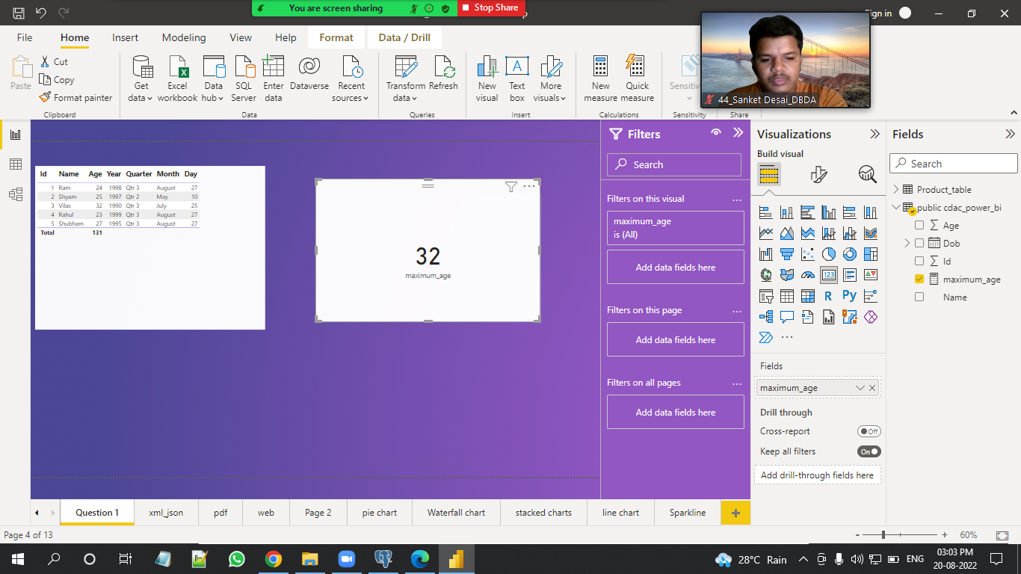

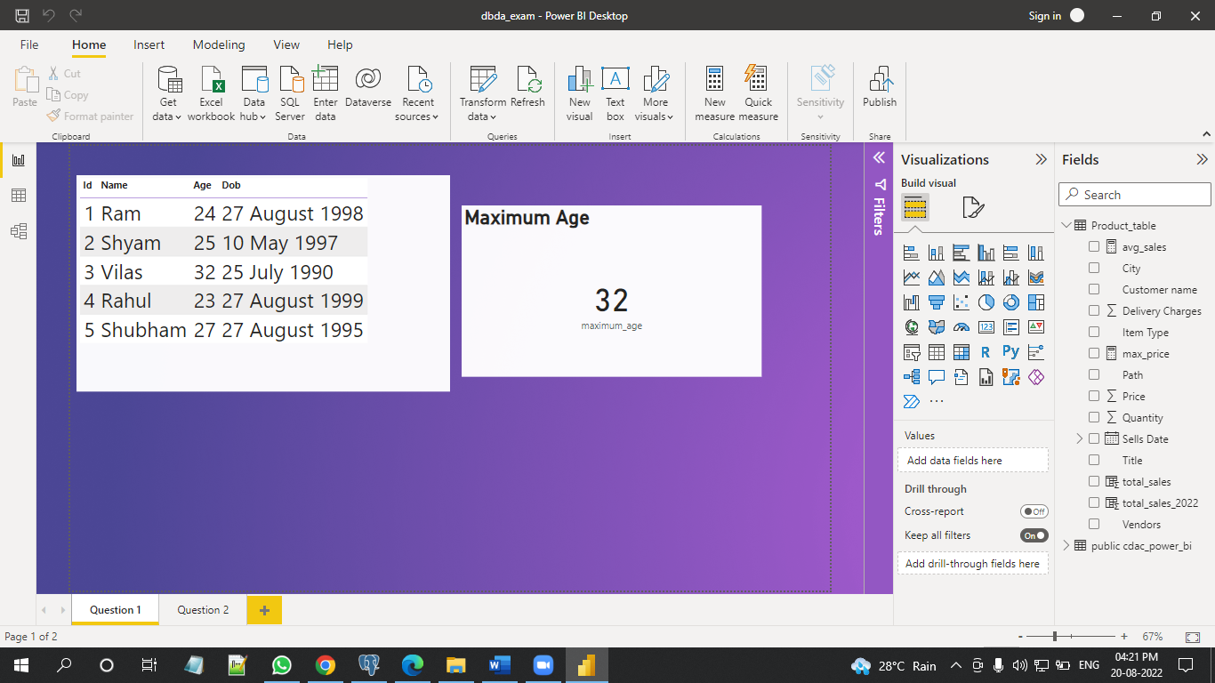

**2. On product_table data set do the following (25 Marks)**

**● Create table chart with title , vendor,customer name,quantity,price,city**

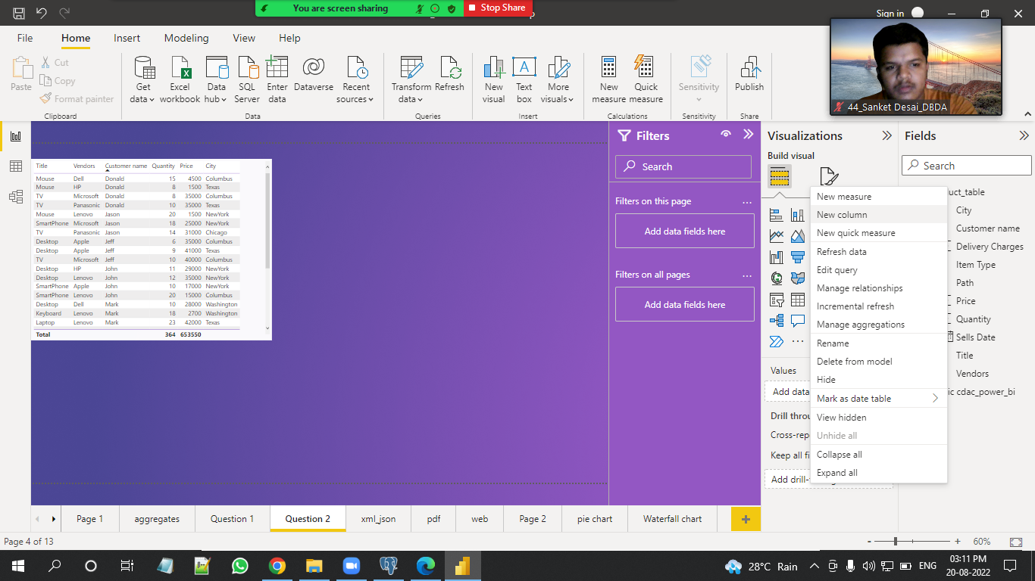

**● Add new calculated column naming total_sales which is derived from quantity * price**

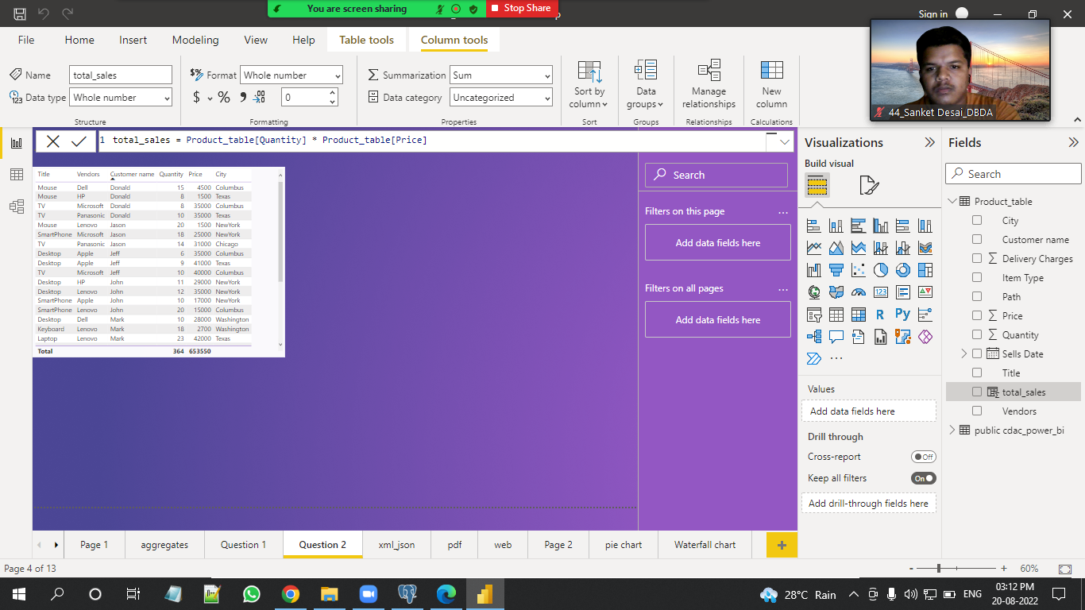

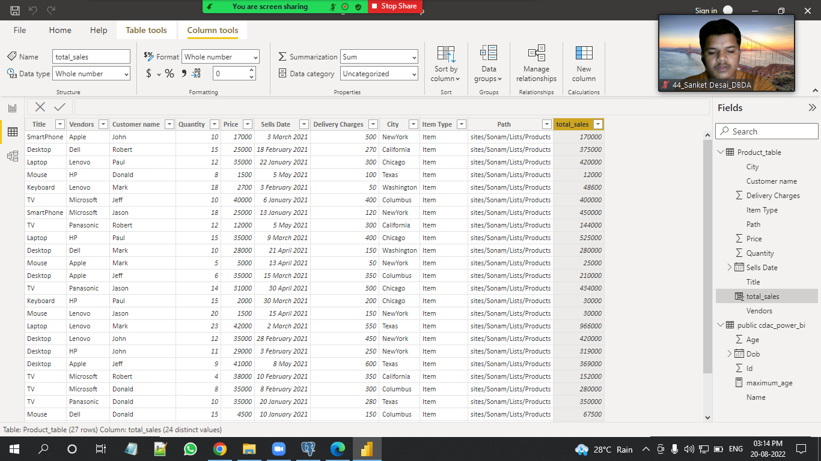

**● Add new measure naming max_price to get max of price column and then display every vendor max price in table chart**

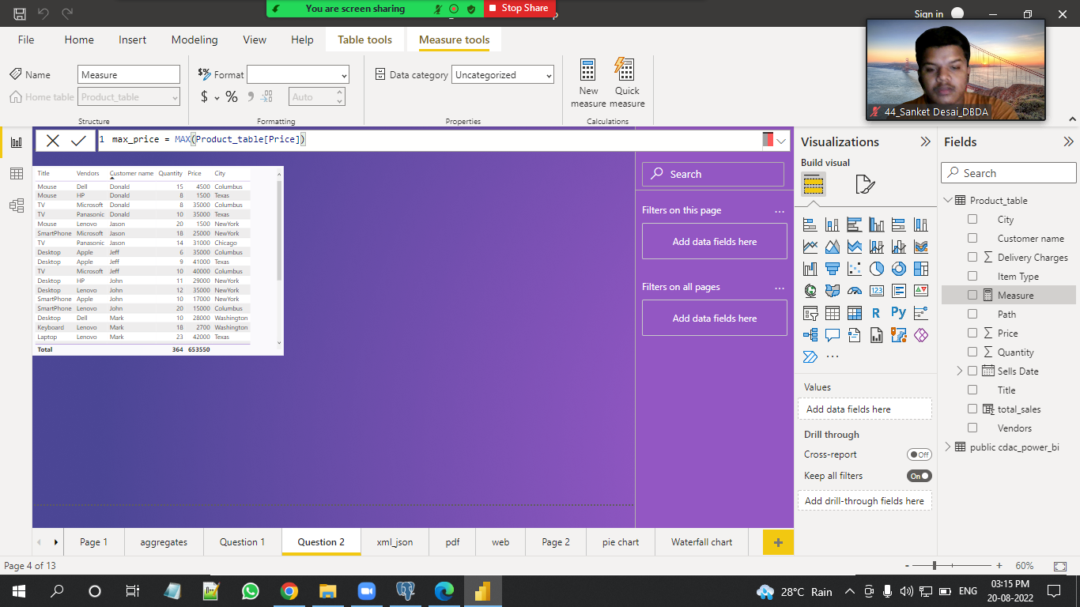

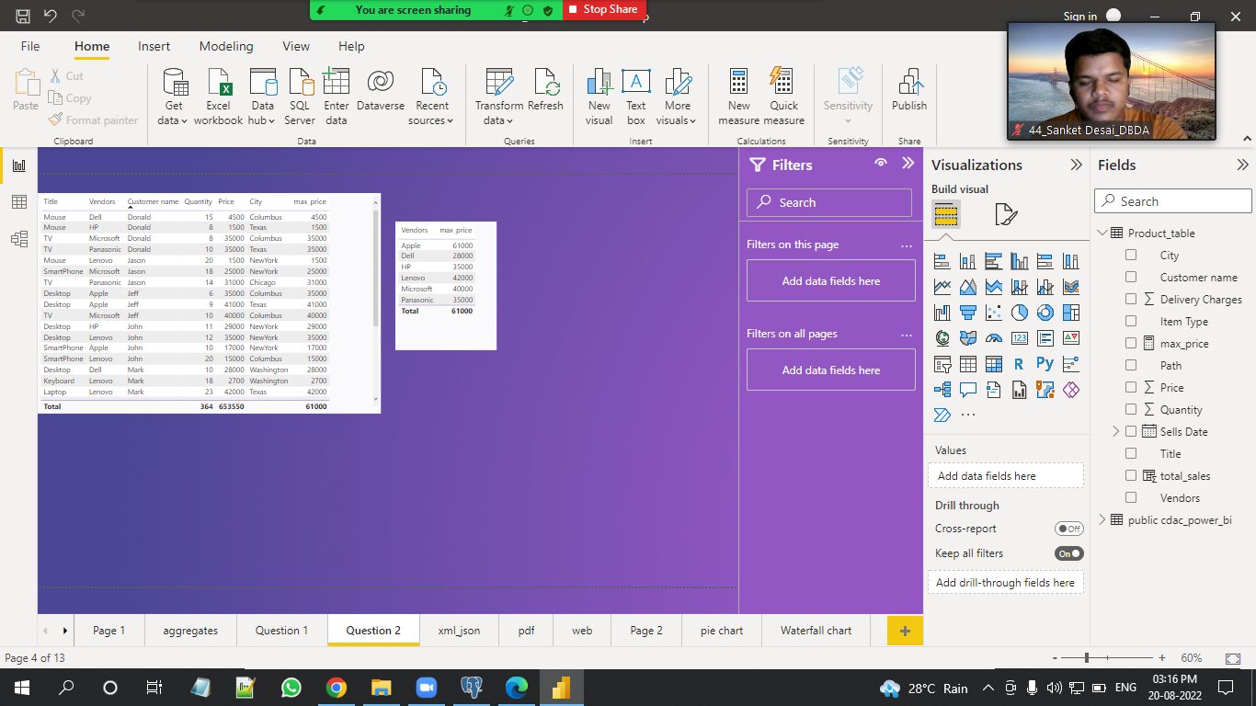

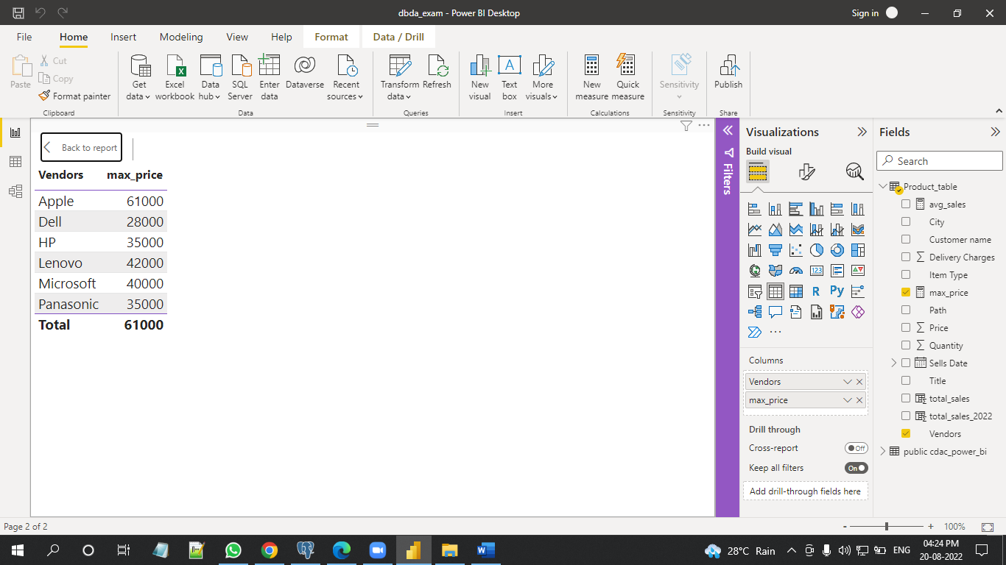

**● Create pie chart showing the value and percentage of quantity by vendors**

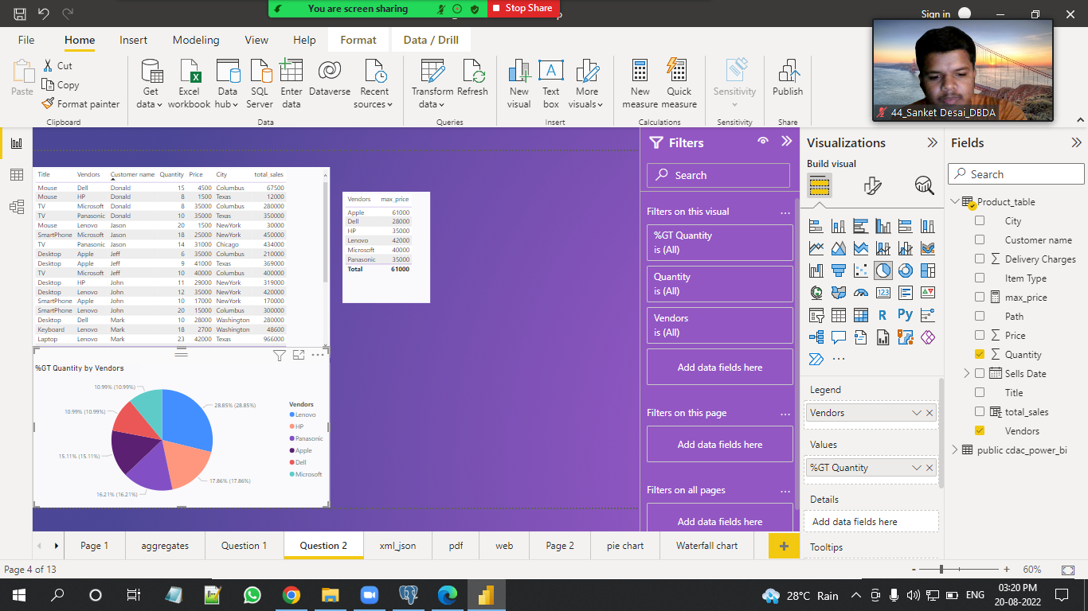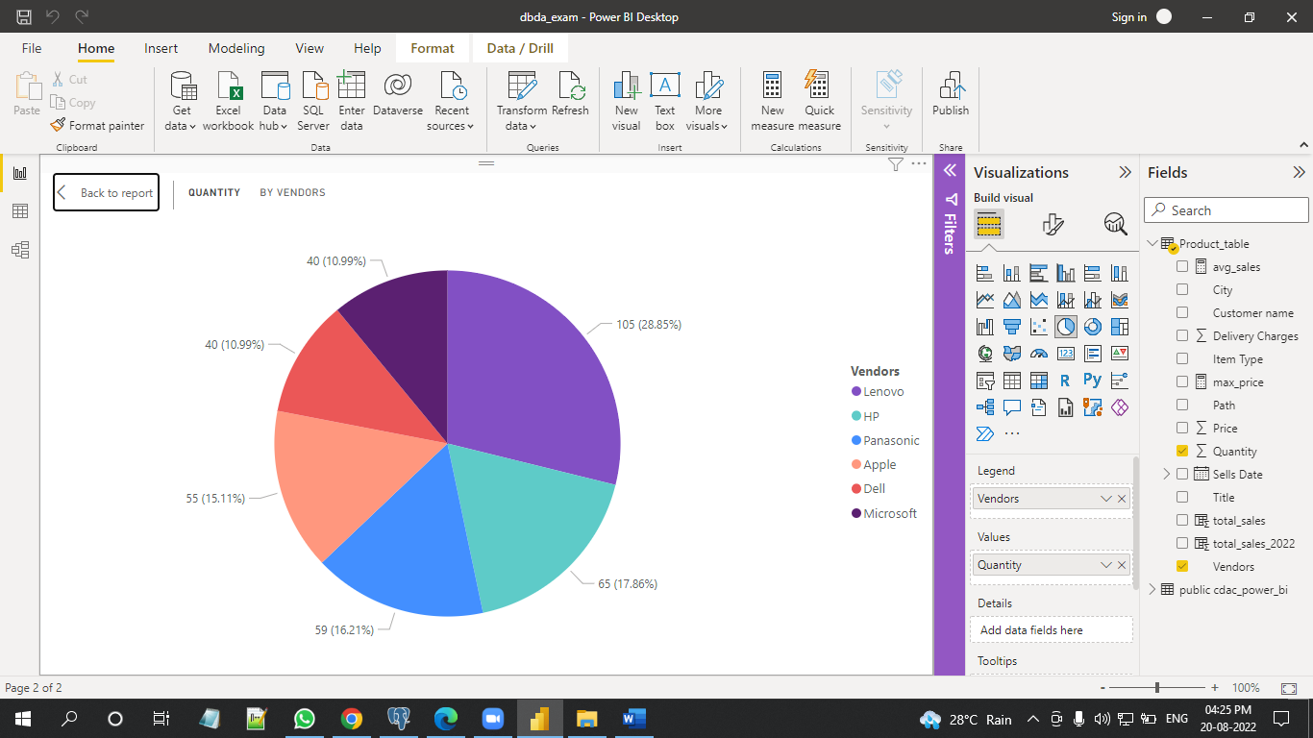

**● Create one more column naming total_sales_2022 which is derived from quantity * price * 1.16**

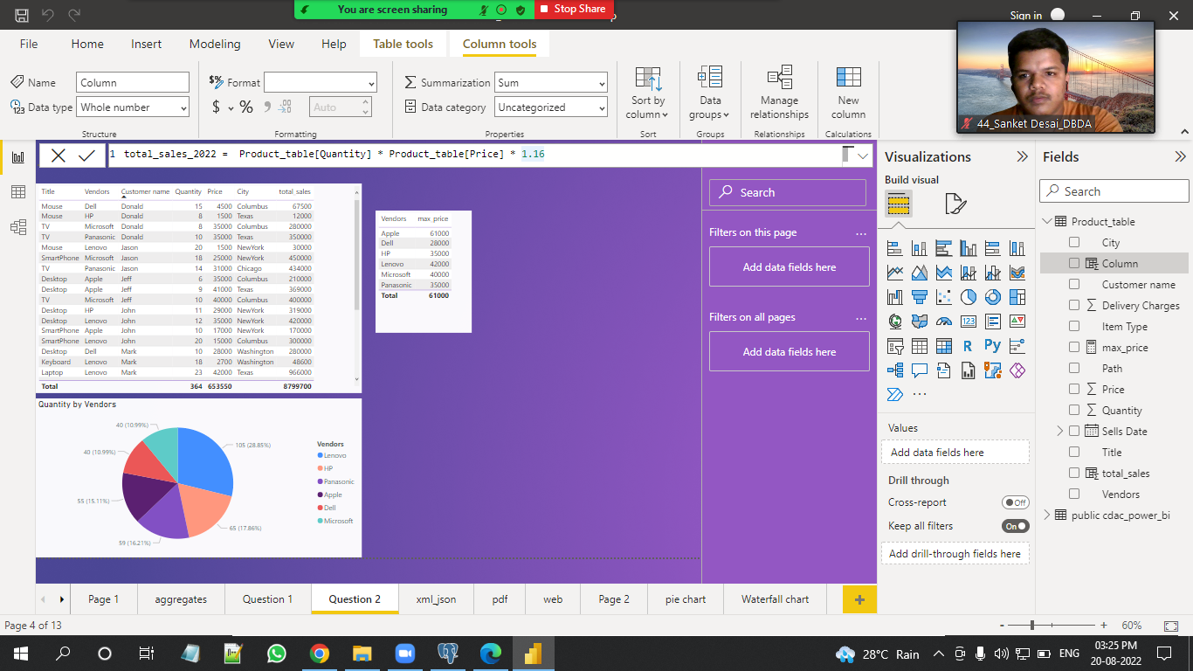

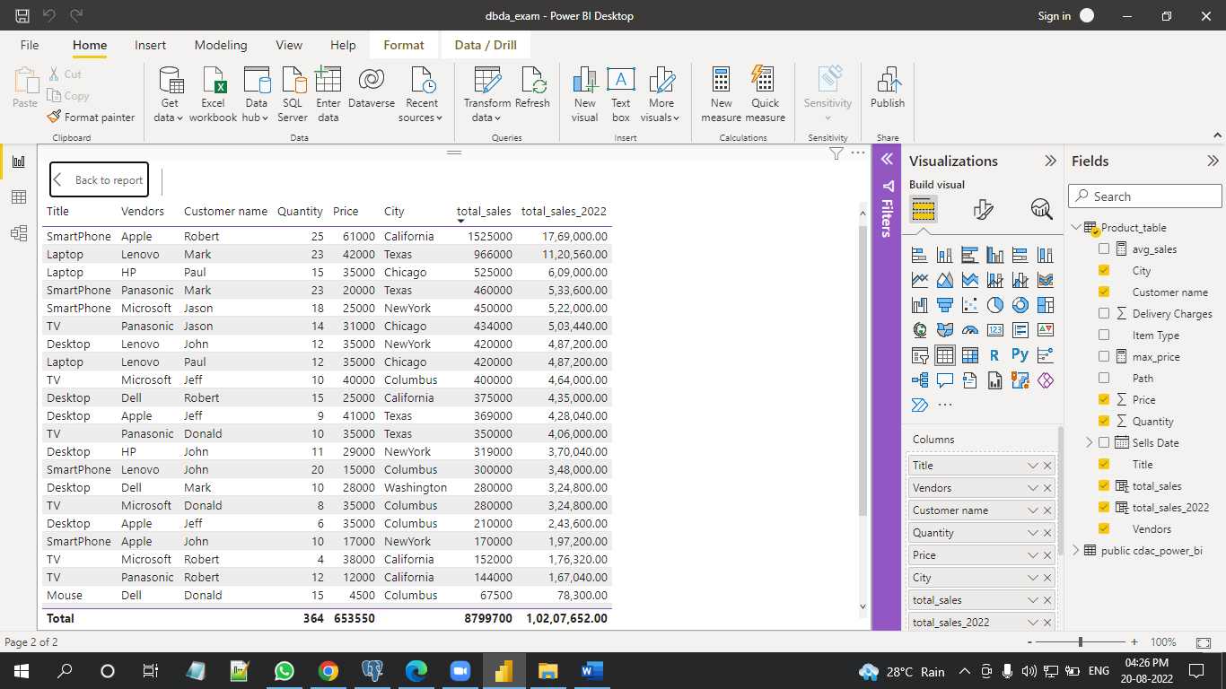

**● Create clustered column chart showing both total_sales and total_sales_2022**

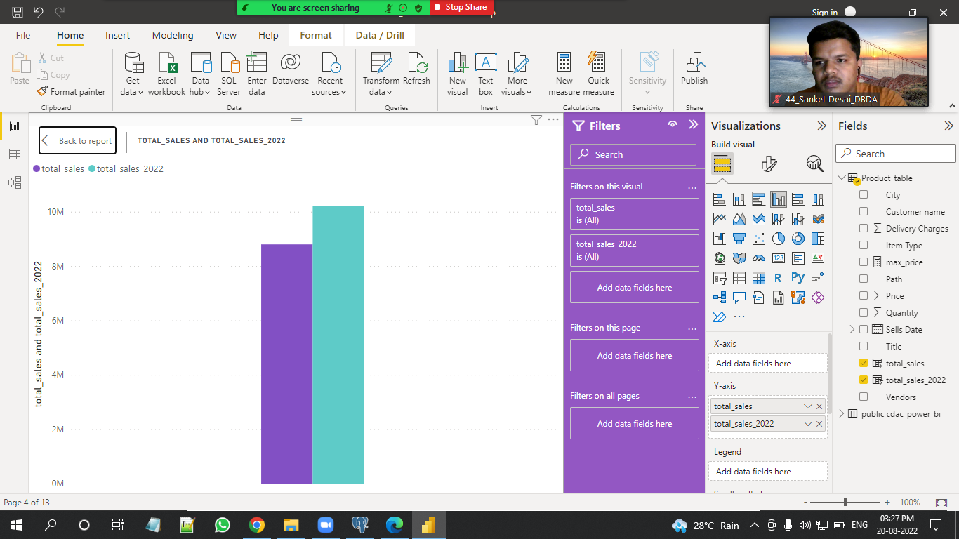

**● Create a slicer chart of price**

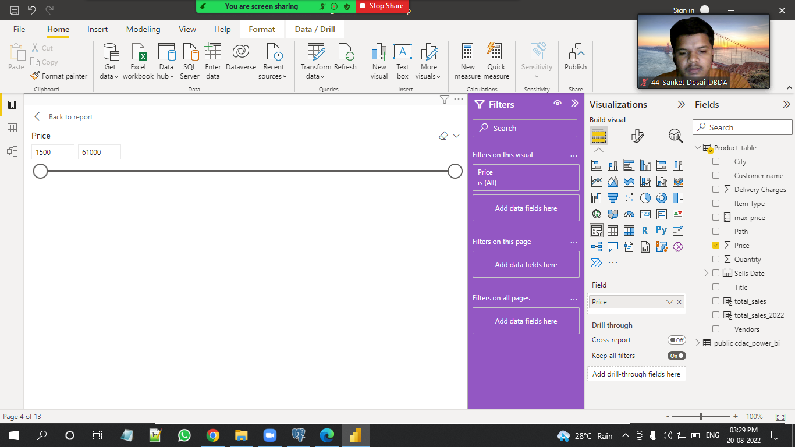

**● Calculate avg sales and show in tile**

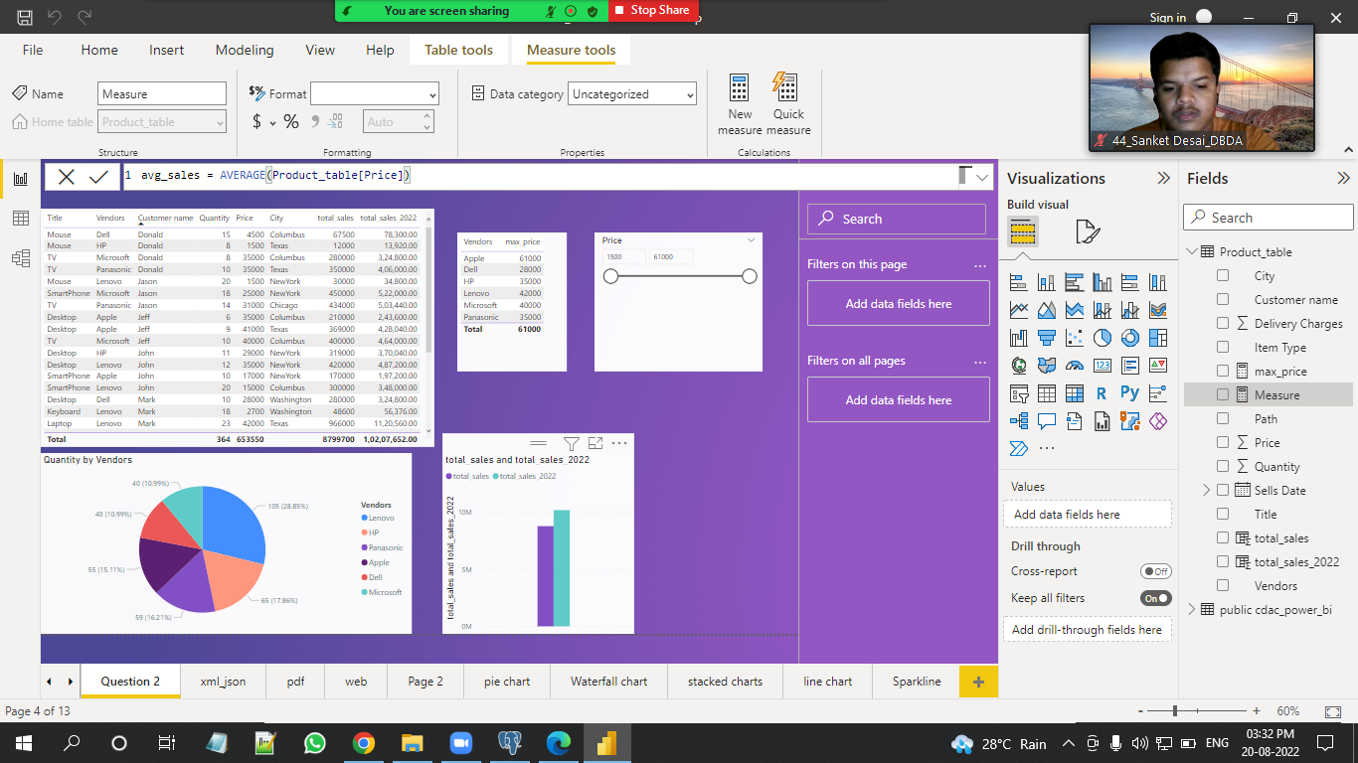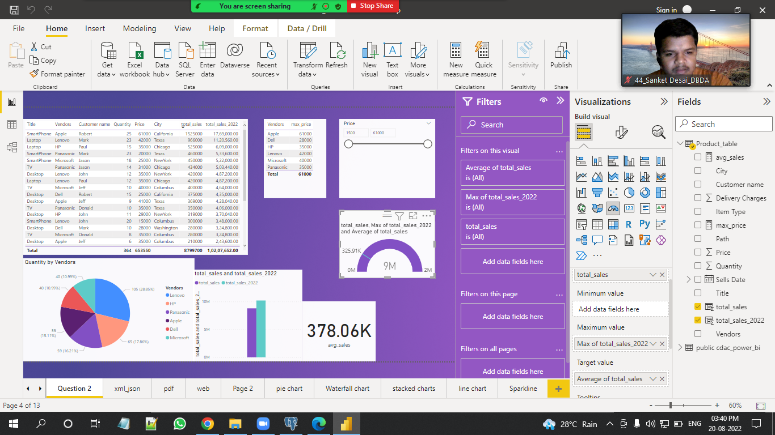

**● Create gauge chart with ○ value as total_sales ○ Maximum value as max of total_sales_2022 ○ Target Value as average of total_sales**

